Cititor cu amprenta SL 2000

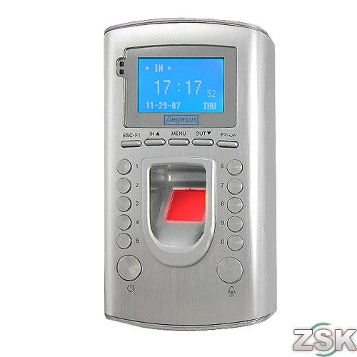

Dimensiune senzor | 16mm*14mm
Dimensiune cititor | 153mm * 85mm * 38mm
Timp scanare amprenta | < 1.2 seconds
Unghi capturare amprenta | ±45°
Viteza verificare | < 1.5 seconds
Rata acceptare amprenta falsa | < 0.0001%
Rata rejectare amprenta valabila | < 0.001%
Metoda | 1:N or 1:n (with GROUP team)
Capacitate stocare modele | 3700 fingerprint templates
Optiune backup | Fingerprint (each individual are allow to 3 fingerprints) or Password
Operare | Standalone
Capacitate LOG In/Out | 50000 Lines
Comunicare | RS232,RS485,TCP/IP, Wiegand 26
Iesire | Wiegand 26,support all Wiegand 26 access controller
Anti-Static Capability | < 40kV
Umiditate operare | 20%-80%
Temperatura operare | -5°C - 60°C
Umiditate stocare | 20%-80%
Temperatura stocare | -10°C - + 65°C
Alimentare | 12VDC@1A with access controller for port 3 or 6V-12V@1A fot port 1
Consum | < 2W
Limbi  (Software system) | Chinese English France Arabic  Thai Hungarian Spanish
Alte functii | Function Keys, In/Out buttons, Bell button, Ports for Bell Ring/Siren, Green and Red light for verification, ports of back up battery use
Greutate | 1.5kg

